Q1
INCLUDE Irvine32.inc

.data
msg BYTE "Product = ", 0

.code
main PROC
push 5
push 4
push 3
call ThreeProd

exit
main ENDP

ThreeProd PROC
push ebp
mov ebp, esp

mov eax, [ebp+8]
imul eax, [ebp+12]
imul eax, [ebp+16]

mov edx, OFFSET msg
call WriteString
call WriteInt
call CrLf

pop ebp
ret 12
ThreeProd ENDP

END main

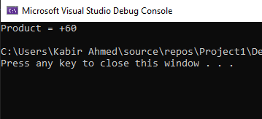
Q2
INCLUDE Irvine32.inc

.data
msgEnter1 BYTE "Enter first number: ", 0
msgEnter2 BYTE "Enter second number: ", 0
msgESP BYTE "ESP = ", 0
msgAns BYTE "GCD = ", 0

.code
main PROC
call TakeInput
exit
main ENDP

TakeInput PROC
mov edx, OFFSET msgEnter1
call WriteString
call ReadInt
push eax

mov edx, OFFSET msgEnter2
call WriteString
call ReadInt
push eax

call ShowESP
call GCD

add esp, 8
ret
TakeInput ENDP

GCD PROC
call ShowESP

push ebp
mov ebp, esp

mov eax, [ebp+8]
mov ebx, [ebp+12]

gcd_loop:
cmp ebx, 0
je done
xor edx, edx
div ebx
mov eax, ebx
mov ebx, edx
jmp gcd_loop

done:
push eax
call Display
pop eax

pop ebp
ret 8
GCD ENDP

Display PROC
call ShowESP

mov edx, OFFSET msgAns
call WriteString
call WriteInt
call CrLf
ret 4
Display ENDP

ShowESP PROC
mov edx, OFFSET msgESP
call WriteString
mov eax, esp
call WriteHex
call CrLf
ret
ShowESP ENDP

END main
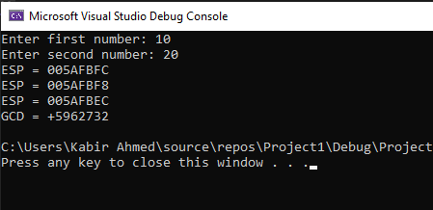
Q3
INCLUDE Irvine32.inc

.data
arr DWORD 11, 22, 5, 44, 1, 9, 87, 12, 14, 18, 33, 2, 55, 10, 7, 90, 3, 8, 6, 50

msgMin BYTE "Minimum = ", 0
msgMax BYTE "Maximum = ", 0

.code
main PROC
push LENGTHOF arr
push OFFSET arr
call MinMaxArray
exit
main ENDP

MinMaxArray PROC
push ebp
mov ebp, esp

mov esi, [ebp+8]
mov ecx, [ebp+12]
mov eax, [esi]
mov ebx, [esi]

findLoop:
cmp [esi], eax
jl setMin
cmp [esi], ebx
jg setMax
jmp next

setMin:
mov eax, [esi]
jmp next

setMax:
mov ebx, [esi]

next:
add esi,4
loop findLoop

mov edx, OFFSET msgMin
call WriteString
mov eax, eax
call WriteInt
call CrLf

mov edx, OFFSET msgMax
call WriteString
mov eax, ebx
call WriteInt
call CrLf

pop ebp
ret 8
MinMaxArray ENDP

END main
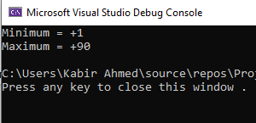
Q4
INCLUDE Irvine32.inc

.data
msg BYTE "Enter a number: ", 0
msgAns BYTE "Square = ", 0

.code
main PROC
call LocalSquare
exit
main ENDP

LocalSquare PROC
enter 4,0

mov edx, OFFSET msg
call WriteString
call ReadInt
mov [ebp-4], eax

mov eax, [ebp-4]
imul eax, eax

mov edx, OFFSET msgAns
call WriteString
call WriteInt
call CrLf

leave
ret
LocalSquare ENDP

END main
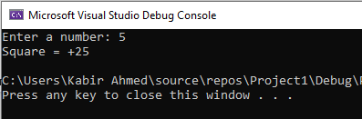
Q5
INCLUDE Irvine32.inc

.data
msg1 BYTE "Enter a number: ", 0
msg2 BYTE "Factorial is: ", 0

.code
main PROC
mov edx, OFFSET msg1
call WriteString
call ReadInt
push eax
call Fact
mov ebx, eax

mov edx, OFFSET msg2
call WriteString
mov eax, ebx
call WriteInt
call Crlf

exit
main ENDP

Fact PROC
push ebp
mov ebp, esp

mov eax, [ebp+8]
cmp eax, 1
jle base_case

dec eax
push eax
call Fact
mov ebx, [ebp+8]
imul eax, ebx
jmp done

base_case:
mov eax, 1

done:
pop ebp
ret 4
Fact ENDP

END main
